Contents

Introduction 2

Functional Requirements (USE-cases) 3

Add Gate 3

Make Connection 3

Remove Gates/connection 4

Clear all 4

Change values of source 5

Save Circuit 5

Open Circuit 6

New Circuit 7

Exit 7

User Interface 8

Main 8

Toolbox 9

Menu 9

Grid 10

Non-functional Requirements 11

# Introduction

Digital Circuit Project is a small part of a big project which deals with the creating and testing of the simple electrical circuits. This document is the part of this project.

This document is focused to how software looks like and how it works. This is all about User Requirements Specifications (URS).

# Functional Requirements (USE-cases)

*Gate means (Source, And, Or, Not, Sink**)**

## Add Gate

Goal: To add Gate

Actor: User

Pre: Application is opened, ***gate selected in toolbox***

Post:

**MSS**:

1. User choose required gate from the Tool Box by clicking.
2. System then mark that as selected
3. User then click in the Grid box in the circuit and the system checks
4. System then paste that gate to that Box in the Grid

**EXT**:

iii. If gate exist already inside the box; system shows message “Overlap not allowed; choose different place”; go to MSS: iii or user choose cancel use case ends.

## Make Connection

Goal: to make connection between source, gate and sink

Actor: User

Pre: Application is opened, at least two items are placed in circuit board

Post: Colored line appears between two points

MSS:



1. Actor choose Make Connection option by clicking from toolbox.
2. Actor clicks the one point on gate
3. And then actor choose another point to connect
4. System checks
5. Connection is done with different color line according to the logical value

EXT:

Iii. If user chose the point that cannot be connected; nothing happens

Use case ends // ***make a message to user***

## Remove Gates/connection

***// make rule***

Goal: To remove the item

Actor: User

Pre: Application is opened, and there is at least one item.

Post: Gate is removed.

MSS:

1. Actor choose the item
2. System mark that item as selected
3. Actor chose delete option from tool box
4. System checks and the selected item is removed

EXT:

iv. If selected item is gate ; that item as well as the connection to and from that gate is also deleted.

## Clear all

Goal: To clean all the items in the circuit

Actor: User

Pre: Application is opened, and there and there is at least one item in the circuit.

Post: The circuit is empty.

MSS:

1. Actor clicks ‘remove all’ button.
2. The system shows message to confirm
3. Actor choose ‘yes’.
4. System checks the circuit ***// don’t have to check again***
5. All items in the circuit is removed

EXT:

1. Actor chooses ‘No’ options; goes to current circuit ; Use case ends.

## Change values of source

Goal: to change the value of input.

Actor: User

Pre: Application is opened, at least one input is placed in circuit

Post: The color of source is changed; sate of source is changed from 1 to 0 or vice versa

MSS:

1. Actor choose the source in the circuit**// by clicking and syste now by clicking**
2. System mark the chosen source
3. User “double-click” on the source to change the state.
4. System checks the whole circuit**// for calculate the color for whole he circuit**
5. System change the color of source from green to yellow or vice versa

EXT:

iii. if double click is not done on source; nothing happens and Use case ends

## Save Circuit

Goal: to save the circuit

Actor: User

Pre: an Application is opened, changes is made in new circuit**// not allowed for more than one application**

Post:

**MSS**:

1. Actor chose Save option from Menu
2. System Opens Save Dialog Box
3. Actor choose the directory where to save the File & gives file name
4. Then the actor clicks save button.
5. System checks and save the file
6. System gives message “successfully saved”.

**EXT**:

iv. Actor choose Cancel. Use case Ends.

v. If file name already exist, system gives message

“File name already exist. Do you want to overwrite?”

Actor choose “YES”, goes to MSS: vi.

Actor choose “No”, goes to MSS: iii.

## Open Circuit **= oke!**

Goal: To open saved circuit

Actor: Users

Pre: Application is open,

Post: Pre-saved circuit is opened

**MSS**:

1. Actor Choose Open option from menu
2. System shows the Open file Dialog Box
3. Actor choose the required circuit file from the directory
4. Actor clicks Open option
5. System checks the circuit
6. Chosen circuit is opened

**EXT**:

iv. Actor choose cancel option. Use case ends

v. if the chosen file is not the good file, system shows message “ File cannot be opened.”

Use case ends.

v. If the chosen file is already open; system shows message “file already opened”.

Use case ends

## New Circuit

Goal: To open a new circuit

Actor: Users

Pre: Application is opened

Post: New working environment is opened

**MSS**:

1. Actor Choose New from Menu.
2. System checks the process
3. System show new circuit to work.

**EXT**:

ii. if pre-opened file is not saved system shows message

“Do you want to save the Pre-opened file before opening New”

Actor choose “Yes”; Goes to “Save” use case.

Actor choose “No”; go to MSS iii.

Actor choose “Cancel”; use case ends

## Exit

Goal: To close the application

Actor: User

Pre: Application is opened

Post: Application is closed

**MSS**:

1. Actor choose exit option from menu
2. System checks the circuit status
3. System close the application

**EXT:**

ii. If the changes made are not save; system shows message

“Do you want to save circuit?”

User choose “No”; go to MSS iii.

If user chose “Yes”; Go to Save use case.

# User Interface

## Main

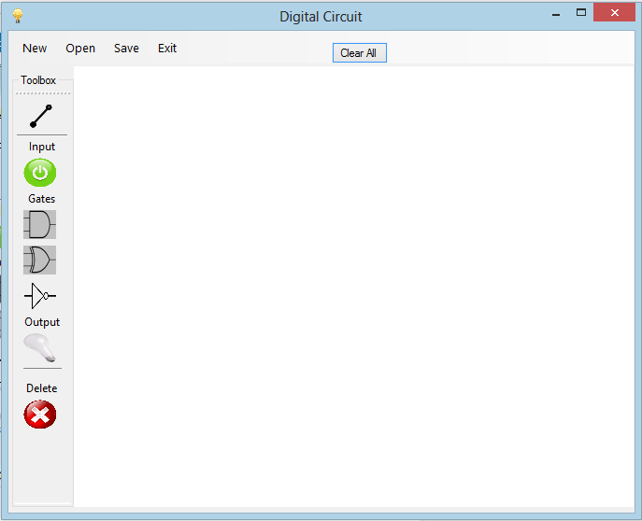

## Toolbox

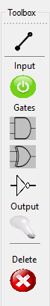

1. **Make connection:**

User click on this tool to make connection between two gates. There are there colors used to make the connection between gates.

1. **Source gate:**

User can place source (input) on circuit; Default value of source is always 1 i.e. green.

1. **And gate:**

User select AND-gate from tool & place in the circuit. It has two inputs and one output

1. **Or gate**

User select this gate and click on circuit to place it there. Or –gate also has two inputs and one output

1. **Not gate**

Not gate has one input and one out put

1. **Sink gate**

sink shows the output value

1. **Delete items**

User choose this tool to delete item from the circuit board.

## Menu



New => opens new circuit

Open => opens saved circuit

Save => save the circuit

Exit => close application

## Grid

We will have a grid on this white space on the application when the application runs.

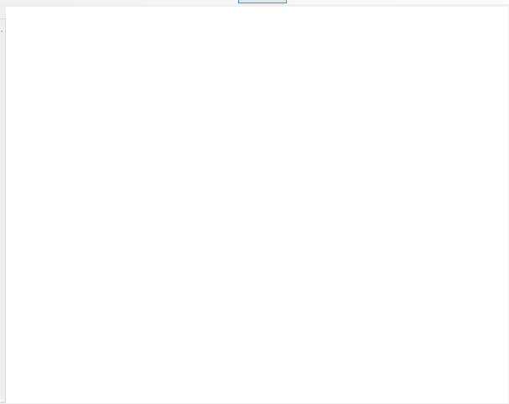

# Non-functional Requirements

# ***// should put more***

=>Design and coding of this assignment will be done in C# language.

System requirement:

=> windows XP , Windows 7 and windows 8

=> 256 Ram

=> 100 MB free space in HDD